ONLINE REAL ESTATE BUSINESS

INDIA'S NO.1 ESTATE PORTAL

[Type the abstract of the document here. The abstract is typically a short summary of the contents of the document. Type the abstract of the document here. The abstract is typically a short summary of the contents of the document.]

Admin

[Type the company name] 1/1/2014



CERTIFICATE



This is to certify that the project report entitled “ONLINE REAL ESTATE BUSINESS” is a bonafide report of the work carried out by Mr. Divyesh Shah under the guidance and supervision for the award of the degree of Bachelor of Information Technology at LDRP Institute of Technology and Research - Gandhinagar, Gujarat.

To the best of my knowledge and belief, this work embodies the work of candidate himself/herself, has duly been completed, fulfils the requirement of the ordinance relating to the Bachelor degree of the university and is up to the standard in respect of content, presentation and language for being referred to the examiner.

Mr. Ashish Patel

Lecturer,

CE - IT Department, LDRP ITR, Gandhinagar

Prof. A.K. Goyal

Head,

CE-IT Department,

LDRP ITR, Gandhinagar

2

CERTIFICATE



This is to certify that the project report entitled “ONLINE REAL ESTATE BUSINESS” is a bonafide report of the work carried out by Mr. Udayraj Gehlot under the guidance and supervision for the award of the degree of Bachelor of Information Technology at LDRP Institute of Technology and Research - Gandhinagar, Gujarat.

To the best of my knowledge and belief, this work embodies the work of candidate himself/herself, has duly been completed, fulfils the requirement of the ordinance relating to the Bachelor degree of the university and is up to the standard in respect of content, presentation and language for being referred to the examiner.

Mr. Ashish Patel

Lecturer,

CE - IT Department, LDRP ITR, Gandhinagar

Prof. A.K. Goyal

Head,

CE-IT Department,

LDRP ITR, Gandhinagar

3

**ACKNOWLEDGEMENT**

The satisfaction and euphoria that accompanies the successful completion of any task would be incomplete without the mention of the people who made it possible. If there is a driving force that kept use going on in doing this project, it is the constant support of our guide Mr. Aashish Patel We present our sincere and heartiest thanks to him, for giving us a patient hearing and clearing our doubts.

We would like to express our profound thanks to Prof. Mr. Aashish Patel for their support and encouragement towards us at every stage in successful completion of our project.

We place our gratitude to our parents who always encouraged us to pursue our interest, who have led us onto the right path. We are undoubted for all the love and affection they bestowed upon us. Many are responsible for the knowledge and experience we have gained during our project and throughout the course. With profound sense of gratitude and regards we acknowledge for support extended by our friends for their support in completion of this project.

Finally, we would also like to thank all those who knowingly or unknowingly helped to us all throughout our project.

4

ABSTRACT

* Our project “ONLINE REAL ESTATE BUSINESS” is related to online application of estate.
* Real estate management system is advanced solution for his/her estate problem.
* User shows all the properties of Buyer that are secure & verify & send them to the Builder.
* Real System Buy the property &verify them and the online service is provided by us free of charge.
* Here registration is also free of cost. So user can registration by using Real System then Buy the property & verify them. After few hours or days our guys put the estate solution.

The software is so reliable to user .Our main concept is give best & quick result to user.

5

**CHAPTER-1** **Introduction**

1. Project purpose

This website is a Online real estate business website through which a user can access its information and manage all the adding, updating, deleting the assets and some of its tasks.

The Admin user can change the update the information regarding property selling and buying and cancellation. The system is very useful for the companies who develope apartments, hotels, villa, residential properties and commercial properties. Companies or individual agents can also advertise their property .

1. Project scope

The real of world wide web have spread across millions of household, so naturally, Internet has become by far the best platform for real estate marketing today.

Now days when everything is online, how is it possible that real estate left web application behind. There are lot of real estate companies who advertise their property online so idea behind developing this application is that their property can also sell,or buy rental property using this. These application are not widely popular but in future,they have large scope of growth.

This website is a online real estate management through which individual agents or buyer can maintain their property document keeping and managing property registration and also access its information and manage all the adding, updating, deleting the as and some of its tasks.The Admin user can inform their agents for regarduing to property and update the information regarding property and cancellation of property or changing buyer choice.

The system is very useful for the companies or builders that can post and edit their properties and their personal info and admin can monitor records of all of them.The system is also useful which also keeps track of Account details of buyers and Investors and also RES Industry.

6

1. Project Objectives

* The system should have a login. A login box should appear when the system is invoked.
* The Admin should have all the type of authority.
* The Admin should maintain property .Admin identify property type as it is residential or commercial property.
* The Admin user can inform their agents for regarduing to property and update the information regarding property and cancellation of property or changing buyer choice.
* The user should book the property for sell or rent with detail of property.
* The system is very useful for the companies or builders that can post and edit their properties and their personal info and admin can monitor records of all of them.
* The system is also useful which also keeps track of Account details of buyers and

Investors and also RES Industry.

1. Project Goals

* Planned approach towards working: - The working in the organization will be well planned and organized. The data will be stored properly in data stores, which will help in retrieval of information as well as its storage.
* Accuracy: - The level of accuracy in the proposed system can not be decided. Because here user buy and another user build the home. There is no guarantee.
* Reliability: - The reliability of the proposed system will be high due to the above stated reasons. The reason for the increased reliability of the system is that now there would be proper storage of information.

7

**CHAPTER-2** **System Requirement Specifications**

1. Scope:

The real of World Wide Web have spread across millions of household, so naturally, Internet has become by far the best platform for real estate marketing today.

Now a days when everything is online, how is it possible that real estate left web application behind? There are lots of real estate companies who advertise their property online so idea behind developing this application is that their property can also sell,or buy or even rent property using this. These applications are not widely popular but in future,they have large scope of growth.

This website is an online real estatemanagement through which individual agents or buyer can maintain their property documentkeeping and managing property registration and alsoaccess its information and manage all the adding, updating, deleting the ads and some of its tasks.The Admin user can inform their agents for regarding to property and update the information regarding property and cancellation of property or changing buyer choice.

The system is very useful for the companies or builders that can post and edit the information of their properties and their personal info and admin can monitor records of all of them. The system is also useful which also keeps track of Account details of buyers and Investors and also RES Industry.

1. Objectives

* The system should have a login. A login box should appear when the system is invoked.
* The Admin should have all the type of authority.
* The Admin should maintain property. Admin identify property type as it is residential or commercial property.
* The Admin user can inform their agents for regarding to property and update the information regarding property and cancellation of property or changing buyer choice.

8

|  |  |
| --- | --- |
|  | • The user should book the property for sell or rent with detail of property. |
|  | • The system is very useful for the companies or builders that can post and edit their |
|  | properties and their personal info and admin can monitor records of all of them. |
|  | • The system is also useful which also keeps track of Account details of buyers and |
|  | Investors and also RES Industry. |
| 2.3 Overall description: | |
| 2.3.1 | Product Prospective: |
| • | Admin’s interface: Admin is a person who will handle the entire website. For that person has to give the user name and password to enter the admin page. After entering right password admin person can enter the admin home area. Here user buy different property & sell them to the system. Buyer user property & builder verify each-other & make reliable communication to each other. |
| • | User’s interface: User can visit the home page of real estate in which first the introduction of our site mention first.The registered user can login from the login module.Here guest can register free account to sell and buy property &buyer verify each- other & make reliable communication to each other. User can search the property and it can select the type of property and its budget and also find the location of property. |
| 2  .3.  2. | Product Functions: |
| • | Our system must save time and money: Accurate upfront software requirements definition helps ensure your team works on the business problems that matter most. |
| • | Reduce rework: Early validation and agreement by stakeholder’s means development and quality teams spend less time on rework. |
| • | Improve requirement accuracy: Industry-unique collaborative storyboarding improves accuracy by promoting effective communication. |
| 2.3.3 Assumptions and Dependencies: | |
| Assumptions: | |
|  | • The code should be free with compilation errors/syntax errors.  9 |

* The product must have an interface which is simple enough to understand. Dependencies:
* All necessary hardware and software are available for implementing and use of the tool.
* The proposed system would be designed, developed and implemented based on the software requirements specifications document.
* End users should have basic knowledge of computer and we also assure that the users will be given software training documentation and reference material.
* The system is not required to save generated reports.

1. Specific Requirements:

Software requirements:

* Any Version of browser after Mozilla Firefox 4.0, Internet Explorer 6.0
* Adobe Flash Player 10.0

Hardware requirements:

* Any processor after Pentium 4.
* Any version of Windows XP or later.

1. Functional And Non-Functional Requirement:

* Functional Requirements :

Since this project uses database and control, it needs the retrieval of information

from the database. It needs access of Database from a front end, as ASP.net is a Microsoft

Family product, it provides easy linking to the database, along with the flexibility required to develop a user-friendly front end.

10

* Functional Requirements

o Usability: The interface should use terms and concepts, which are drawn from the

experience of the people who will make most of the system.

o Efficiency: The system must provide easy and fast access without consuming

more cost.

o Reliability: User should never be surprised by the behavior of the system and it‘s easy to use to stored data and easy to used transfer voice data (only .wav files)

1. System attributes:

* Reliability

This system is designed to have very simple database just to cater the exact need of real estate management. It is tested for all the constraints at development stage.

* Availability

This system will only available till the system on which it is installed is running.

* Security

This system is provided with authentication without which no user can pass. So only the legitimate users are allowed to use the application. If the legitimate users share the authentication information then the system is open to outsiders.

* Maintainability

There will be no maintenance required for the software. The database is provided by the end-user and therefore is maintained by this user.

* Portability

The system is not portable as it is a standalone application running on single system with no shared database.

11

**CHAPTER-3** **System Design**

1. Class Diagram

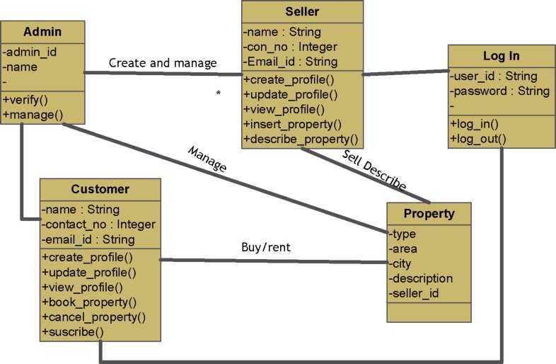

12

3.2 Use-Case Diagram

1. ADMIN Use-Case

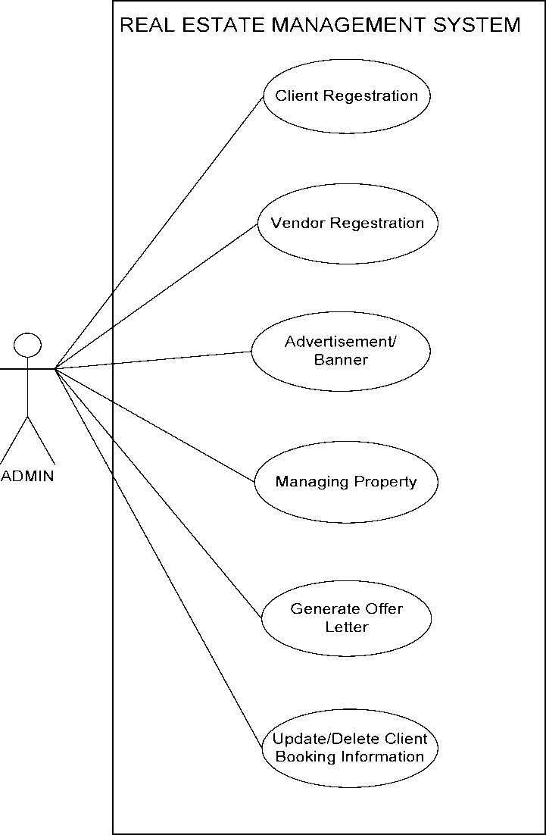

13

1. USER Use-Case

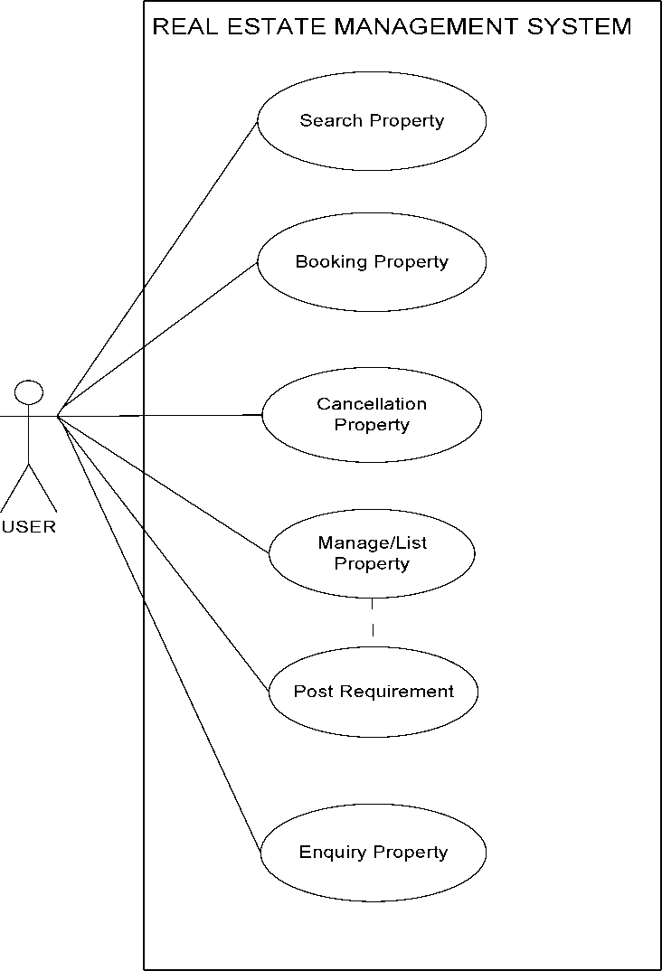

14

3.3 Sequence Diagram

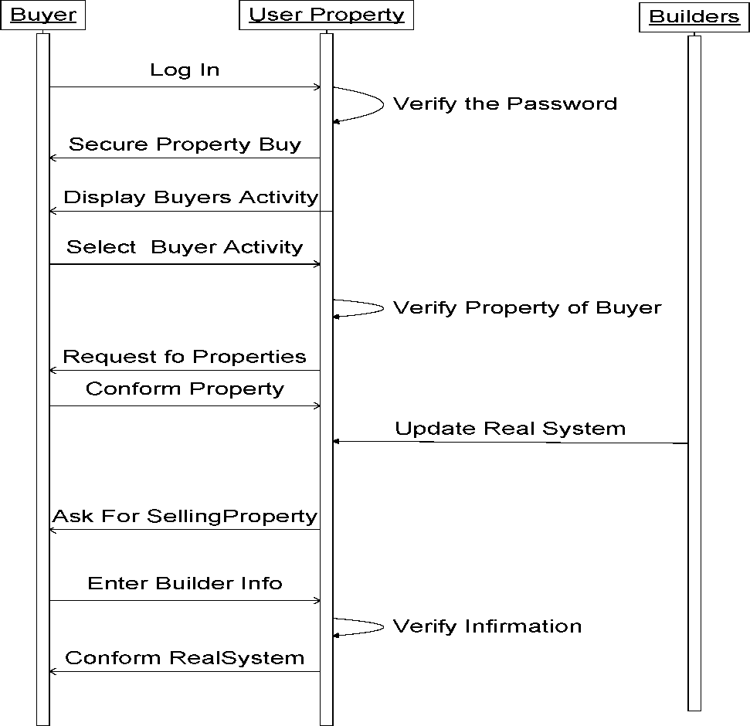

15

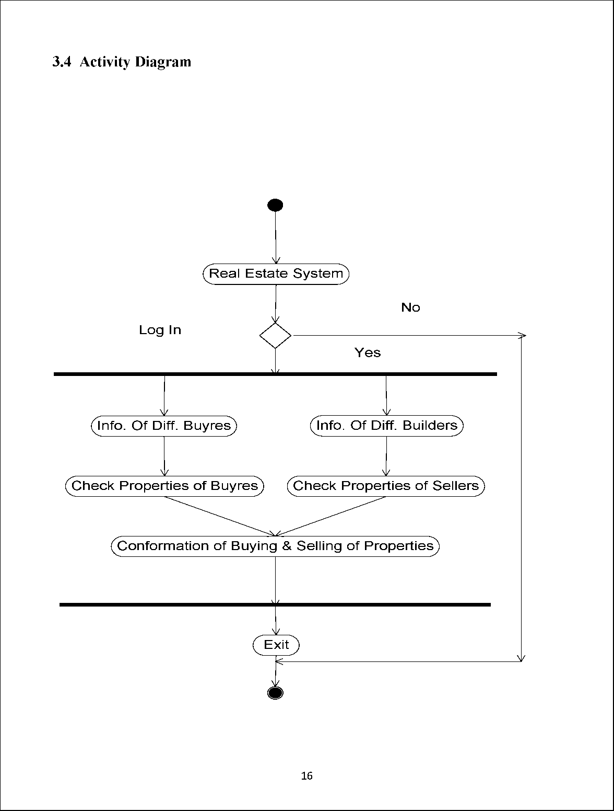

1. Data Flow Diagram:

* Level 0 (DFD CONTEXT):

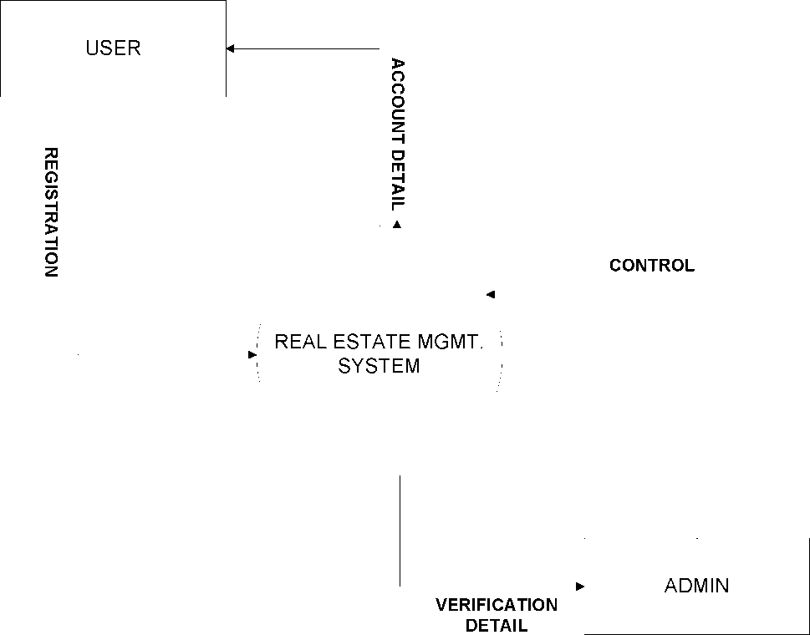

17

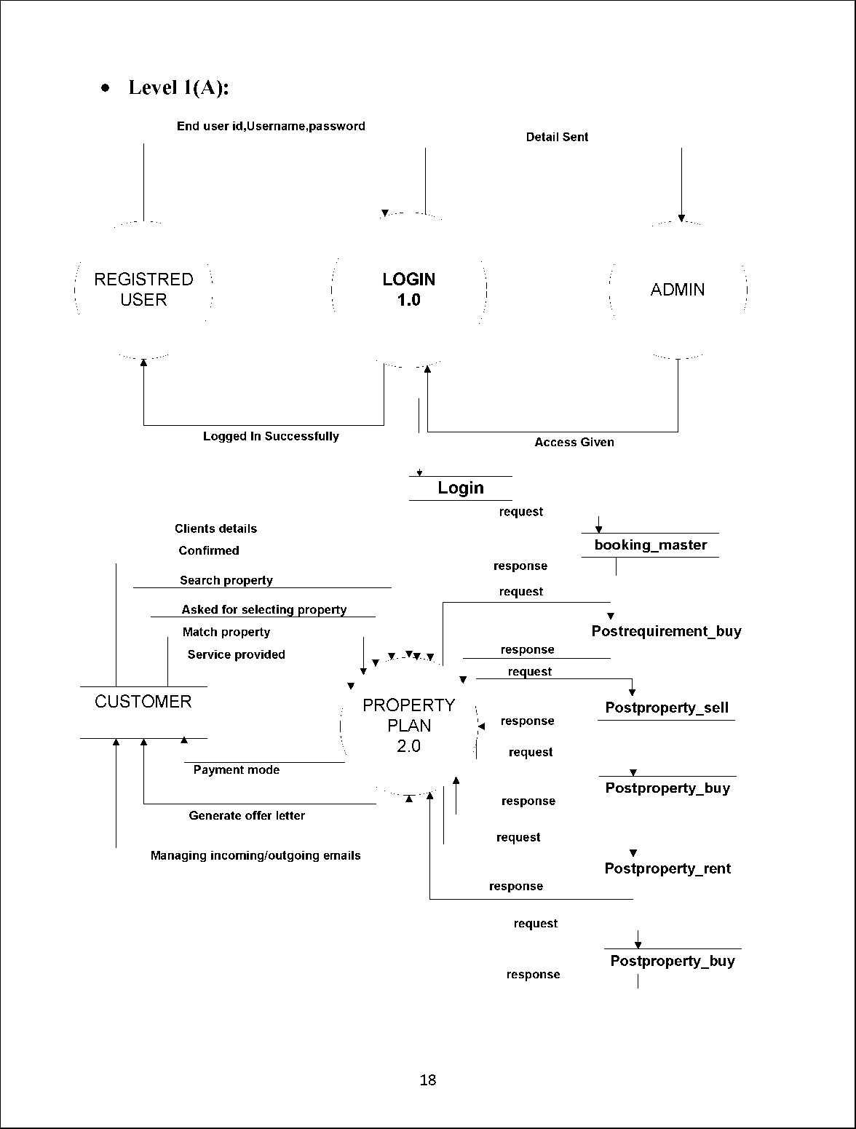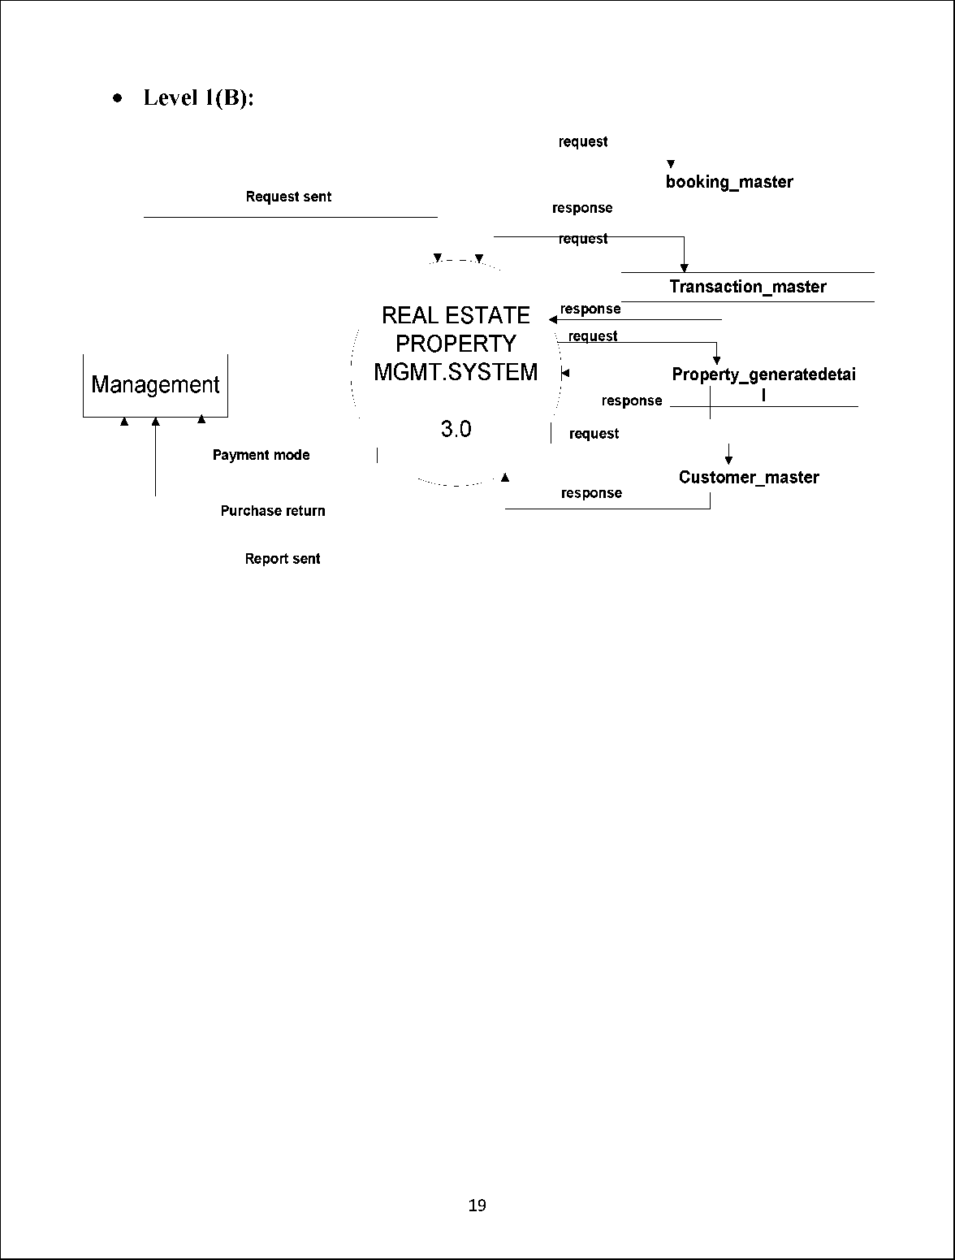

* Level 2(A):

Enter user id,username,password Details sent

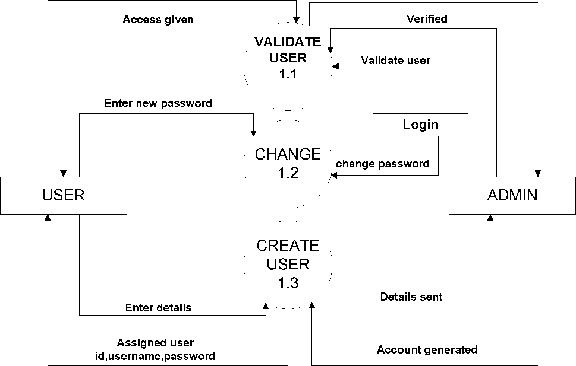

20

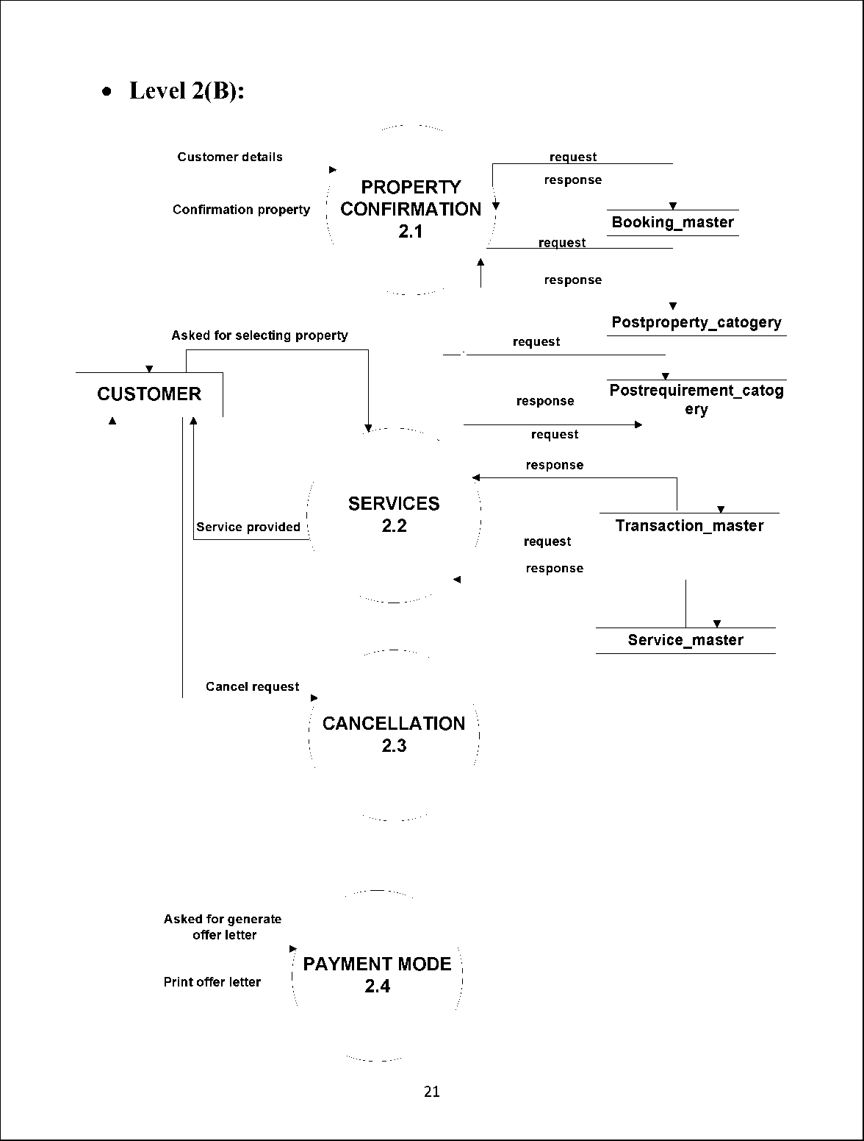

1. Data modeling
2. Data Dictionary

Data Dictionaries are an integral component of analysis, since data flow diagram by him or she does not fully describe the subjects of the investigation.

A data dictionary is a catalog of the element in as system. This element centers on data and the way are structured to meet user‘s requirements and needs. The major elements are dataflow, data stores and processes. Data dictionary stores details and description of these elements.

It is developed during data analysis and assists analysis involved in determining the system. Four main reasons of analysis are:

* To manage the details in large system.
* To communicate a common meaning for all system elements.
* To document the features of the system.
* To locate the errors and omissions in the system.

The data dictionary contains two types of descriptions as following:

1. Data Elements: The most fundamental data level is the data element. Data element is the building block for all others in the system.
2. Data Structure: A data structure is a set of items that are related to one another that describes components in the system.

22

Table Name: Postproperty_sell Primary Key: sell_id

Description: To store the details of seller or agents.

|  |  |  |  |
| --- | --- | --- | --- |
| Sr_No | Fields | Datatype | Description |
| 1 | Property_type | Varchar(50) | Residential or commercial property |
| 2 | City | Varchar(50) | User city name |
| 3 | Locality | Varchar(50) | Area of user |
| 4 | Address | Varchar(50) | Detailed address of User |
| 5 | Type_of_owners | varcharr(50) | No. of bedrooms |
| 6 | Ploat_area | Double(50) | Area of land |

Table 1: Postproperty_sell

23

Table Name: Postproperty_rent Primary Key: sell_id

Description: To store the details of the person who rent their property .

|  |  |  |  |
| --- | --- | --- | --- |
| Sr_No | Fields | Datatype | Description |
| 1 | Property_type | Varchar(50) | Residential or commercial property |
| 2 | City | Varchar(50) | User city name |
| 3 | Locality | Varchar(50) | Area of user |
| 4 | Address | Varchar(50) | Detailed address of User |
| 5 | Bedrooms | Int(20) | No. of bedrooms |
| 6 | Furnished | Varchar(50) | Furnished or not |
| 7 | Age_of_construction | Double(20) | Describe the building age |
| 8 | Plot_area | Double(50) | Area of land |
| 9 | Monthly_rent | Double(20) | Rent per month |

Table 2: Postproperty_rent

24

Table Name: Postrequirement_buy Primary Key: login_id

Description: To store the details of the person for requirent of property.

|  |  |  |  |
| --- | --- | --- | --- |
| Sr_No | Fields | Datatype | Description |
| 1 | Buyer_id | Int(20) | Id of buyer |
| 2 | State | Varchar(50) | State of buyer |
| 3 | Bedrooms | Int(20) | No . of bedrooms |
| 4 | Area | Double(20) | Area of land |
| 5 | Budget_min | Varchar(50) | Minimum amount of land |
| 6 | Budget_max | Varchar(50) | Maximum amount of land |
| 7 | Login_id | Int(20) | User login id |

Table 3 :Postrequirement_buy

25

Table Name: Postrequirement_sell Primary Key: login_id

Description: To store the details of the person for requirent of selling property.

|  |  |  |  |
| --- | --- | --- | --- |
| Sr_No | Fields | Datatype | Description |
| 1 | Property_type_ | Varchar(50) | Residential or commercial property |
| 2 | City | Varchar(50) | User city name |
| 3 | Locality | Varchar(50) | Area of user |
| 4 | Address | Varchar(50) | Detailed address of User |
| 5 | Bedrooms | Int(20) | No. of bedrooms |
| 6 | Bathrooms | Int(20) | No. of bathrooms |
| 7 | Login_id | Int(20) | User login id |

Table 4: Postrequirement_sell

26

1. E-R Diagram:

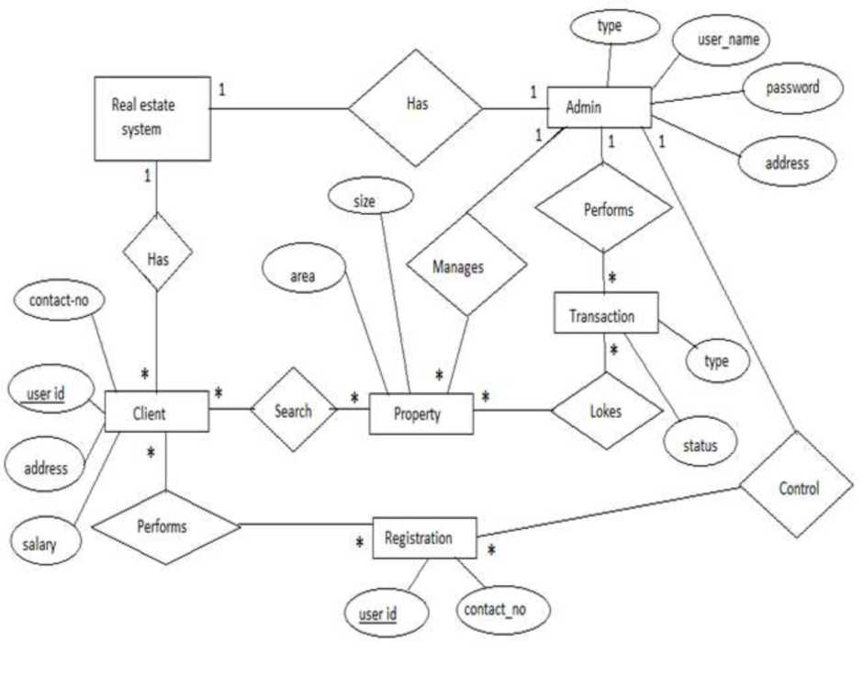

2i

**CHAPTER-4**

**TESTING**

1. TEST CASES:

* Unit Testing: This is the lowest level of testing that is conducted to remove syntax & logic errors from a single unit. Individual components are tested to ensure that they operate correctly. Each component is tested independently, without other system components.
* Module testing: A module is a collection of dependent components such as an object class, an abstract data type or some looser collection of procedures & functions. A module encapsulates related components, so can be tested without other system modules.
* Sub-System testing: This phase involves testing collections of modules, which have been integrated into sub-systems. This tests for problems that arise from component interactions. This testing should begin as soon as usable versions of some of the system components are available.
* System testing: The sub-systems are integrated to make up the system. The system as a complete entity is tested over here. This process is concerned with finding errors that result from unanticipated interactions between sub-systems. It is also concerned with validating that the system meets its functional & non-functional requirements & testing the emergent system properties.
* Acceptance testing: This is the final stage in the testing process before the system is accepted for operational use. The system is tested with data supplied by the system customer rather than simulated test data. Acceptance testing may reveal errors & omissions in the system requirements definition because the real data exercise the system in different ways from the test data. It may also reveal requirements problems where the system’s facilities do not really meet the user’s needs or the system performance is unacceptable.

28

CHAPTER 5

RESULT

1. Snapshots of this Website:-

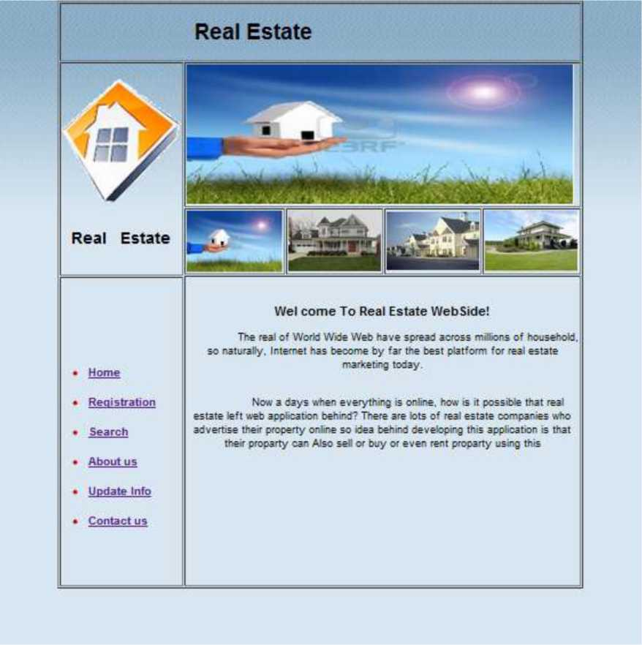

Home Page

29

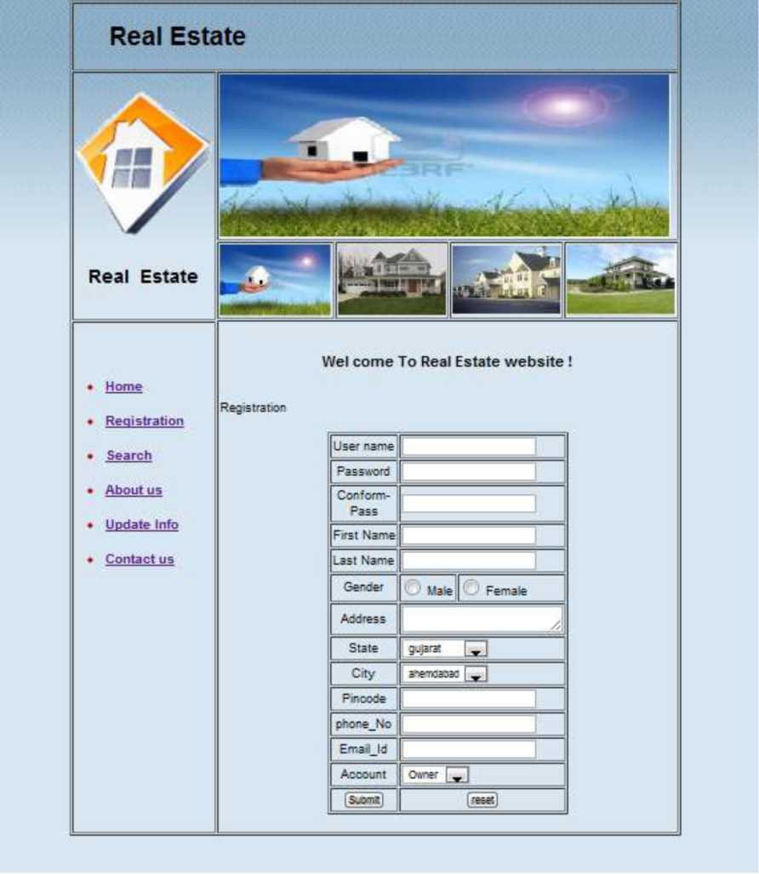

Sign up page

30

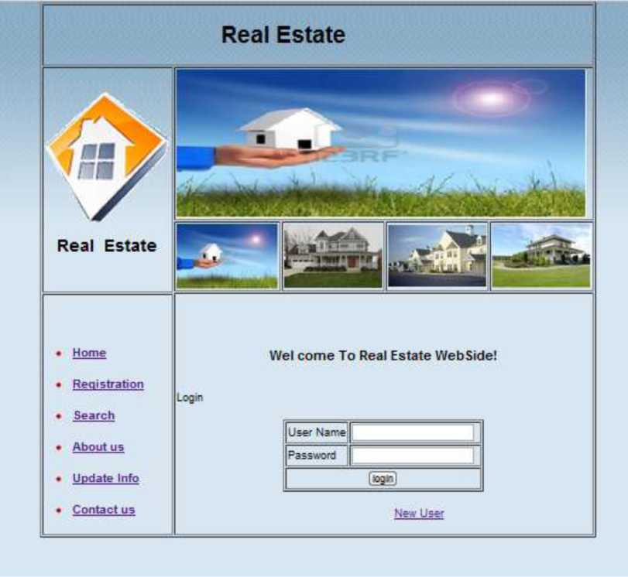

Login page

31

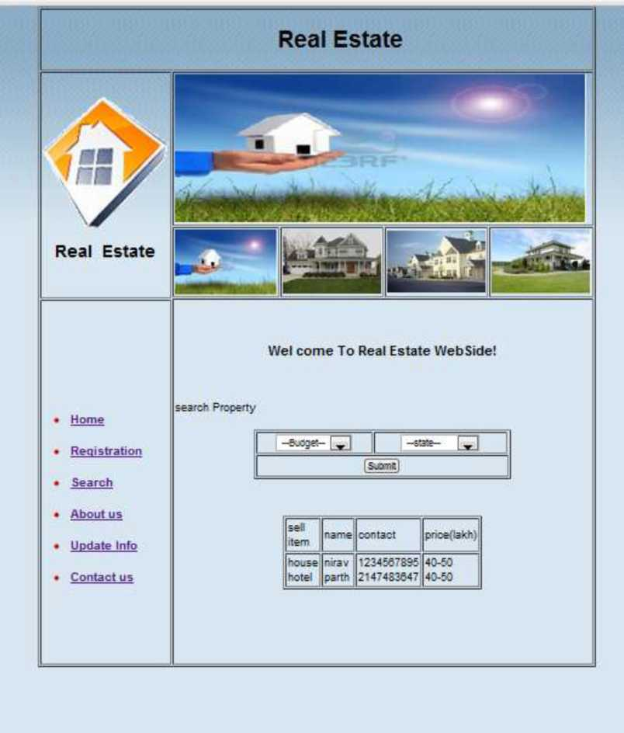

Search page

32

**CHAPTER 6** CONCLUSION AND DISCUSSION

1. Self-Analysis of Project Viabilities

Definitely, it's cheaper to use online Mobile shopping for both personal and business use because most of it is usually free.

1. Problem Encountered and Possible Solutions

* Hardware Limitations

The only limitation posed is when the disk space is exhausted. And it can be solved by extending the disk space.

* Internet speed

Internet connection speed should be minimum 128 kbps.

1. Summary of Project work

In whole procedure to prepare project, we first gather the requirement of the project and decide the time schedule. After planning we design the documentation of project. After the design we generate the code of system. In design the code we do the error estimation and effort estimation. If error is occur then solve it. Finally when code is designed then test the project and decide the cost of project.

33

**References/Bibliography**

Author:

* Software Engineering: A Practioner’s Approach 6th edition by Roger Pressman, McGraw Hill international edition.
* The Object Oriented Approach Concepts, System Development and Modeling with UML, Satzinger, Orvik, 2nd edition.

Web Links:

* [www.g](http://www.infosurv.com/)oogle.com
* [www.wikipedia.com](http://www.wikipedia.com)
* [www.real-estate-management-system.nic.in](http://www.real-estate-management-system.nic.in)
* [www.project-management-basics.com](http://www.project-management-basics.com)

34